40.34: a) 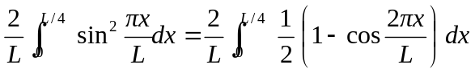
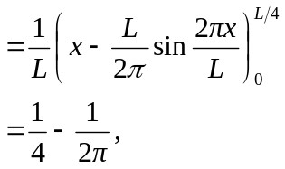
about 0.0908.
b) Repeating with limits of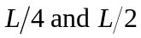 gives
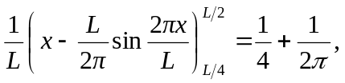
about 0.0409. c) The particle is much likely to be nearer the middle of the box than the edge. d) The results sum to exactly 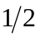, which means that the particle is as likely to be between 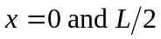as it is to be between 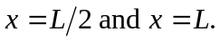 e) These results are represented in Fig. (40.5b).

